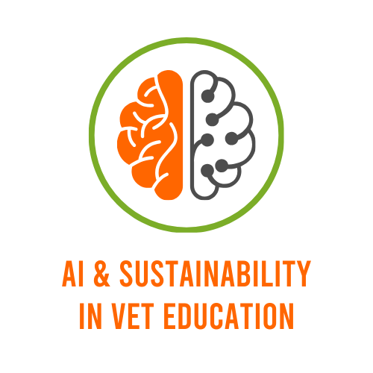

AI-VET Mooc Project Submission Template

AI-VET Mooc Project Submission Template
This template provides a structured format for submitting final projects within the AI-VET MOOC. Each section should be completed thoroughly to ensure consistency and to provide all the necessary information for project evaluation, peer review, and sharing within the course community.
Participants are encouraged to use this template to present their innovative ideas, learning experiences, and applications of Artificial Intelligence in Vocational Education and Training (VET).
All sections written in grey contain instructions and examples to guide the preparation of your project report. These notes must be deleted before submission. The final document must be a technical project report, with a maximum length of twenty (20) pages, including text, figures, and references.

1. Project Title: Plastic Bottle Detection

2. Project Category: AI for Sustainable Development
•

3. Project Description:

Robot that detects plastic waste using a self-hosted custom made AI and avoids obstacles using an ultrasonic sensor.

4. Keywords:

AI Vision, YOLO, plastic waste, Raspberry Pi

5. Target Audience:

Students

6. Project Objectives:

Learning Python programming, object detection using YOLO, using Linux, connecting electrical modules with Raspberry Pi.

7. Project Timeline:
Provide a brief overview of the project timeline: start and end dates
- Start Date: 1. 02. 2026
- End Date: 13. 03. 2026

8. Tools and Technologies Used:
PiCamera2, Ultralytics YOLO
1- AI-VET Kit Components:
Raspberry Pi 5- 8gb, 2WD Robotic kit, MicroSD card 64gb, motor driver module, mini breadboard, microservo SG90, HC-SR04P Ultrasonic sensor, Raspberry Camera v3

2- Programming Environments:
Python

3- AI and Machine Learning Tools (if applicable):
PyTorch

4- Datasets:
Self-made image dataset

9. Step-by-Step Implementation Plan:
1. Concept and Planning
The goal was to create a robot capable of identifying plastic waste using AI. The idea combines robotics and computer vision to address environmental challenges.
A simple navigation system was planned:
Detect plastic bottles using AI
Avoid obstacles using ultrasonic sensor
Move autonomously

2. Hardware Setup – Using the AI-VET Kit
Connected motors to the motor driver module
Linked motor driver to Raspberry Pi GPIO pins
Mounted Raspberry Pi Camera v3
Connected HC-SR04P ultrasonic sensor to GPIO
Assembled robot chassis and power supply
Special care:
Correct voltage supply to Raspberry Pi
Secure wiring for stable movement
Calibration of ultrasonic sensor distance readings

3. Data Collection and Preparation
Captured images of plastic bottles in different environments
Included various angles, lighting conditions, and backgrounds
Labeled images using annotation tools
Applied transfer learning using YOLO for faster training

4. Programming and AI Configuration
Programmed in Python
Used Ultralytics YOLO for object detection
Implemented key functions:
Camera input capture
Real-time object detection
Distance measurement using ultrasonic sensor
Motor control for movement and obstacle avoidance

5. Testing and Validation
Tested in indoor and outdoor environments
Verified detection accuracy under different lighting conditions
Measured:
Detection accuracy
Response time
Obstacle avoidance reliability
Adjustments made:
Improved dataset quality
Tuned detection confidence threshold
Adjusted sensor distance limits

6. Final Demonstration and Reflection
Results:
Successfully detects plastic bottles in real time
Navigates while avoiding obstacles
Demonstrates integration of AI + robotics
What worked well:
YOLO model provided fast and accurate detection
Raspberry Pi handled real-time processing effectively
Challenges:
Limited processing power required optimization
Lighting conditions affected detection accuracy

Future Improvements:
Add robotic arm to collect waste
Improve model accuracy with larger dataset
Add GPS for outdoor tracking
Integrate cloud dashboard for monitoring

11. Evaluation Criteria:
1. Student Feedback:
Understanding of AI and robotics concepts
Engagement during project development

2. Project Success Metrics:
Accurate detection of plastic bottles
Successful obstacle avoidance

3. Skills Assessment:
Python programming proficiency
Hardware assembly skills
AI model training understanding

12-Credits
Students:
Ilija Dimov
Ivan Ivanov
Teo Ilievski
Andrej Ristevski
Matej Stoimenov

Teachers:
Roza Vojnovska
Zoran Zafirov

13- Video presentation link
https://youtu.be/OS1uzYV5ok8

14- Declarations
I declare that I have read and agree with the following statements:

1- The project is original and developed by the listed team members.
2- All technologies and sources are properly cited.
3- The project was developed using components from the AI-VET kit.
4- We authorize the dissemination of the project for educational and promotional purposes (non-exclusive rights).

